ASR 7045

New CS label – hypoint product

**Update 2018-03-29: From:** Karena Han [<mailto:Karena_Han@bd.com>]   
**Sent:** Thursday, March 29, 2018 2:30 PM  
**To:** Jack, Fong; Rahamat, Mohd Syaiful Adli  
**Cc:** Tan, Wee Jian; Kio, Xi Xiang; Tat Shin Vun; Teck Seng Tan; Chan, Pei-Fong  
**Subject:** RE: New labeling content for Hypoint product (India Labeling)

Hi Jack,

## Please find the updates for hypoint labeling.

Please start the system set up and provide me a update by 6 Apr 2018 as per mention 5 man day to set up WMS.

SCH_SKU_LABELING SKULABEL

SCH_IMPORTER_CUSTOMER IC

SCH_SKU_LABEL_BATCH_EXPIRY - INVBATCH

|  |  |  |  |  |  |  |
| --- | --- | --- | --- | --- | --- | --- |
| Fields needed in the labels | Where to we obtain the information? | | Remarks | | WMS Mapping | |
| No of Units | 5000 Units | | Fix information | | SKU. QtyPerCarton | |
| Catalog Number | Applicable to these 4 Hypoint SKU | | SKU 300255  SKU 300249  SKU 300264  SKU 300253 | | SCH_SKU_LABELING.SKU | |
| Mfg date | From  COA-COC | | RDC process is to be obtain date from source | | SCH_SKU_LABEL_BATCH_EXPIRY.  manufacturingDate | |
| Expiry date | From  COA-COC | | RDC process is to be obtain date from source | | SCH_SKU_LABEL_BATCH_EXPIRY. Expirydate | |
| Month & Year of import | From Planner | | To be confirm | | TBC {print-date} | |
| Manufacturing site | BECTON DICKINSON MEDICAL (SINGAPORE) PTE LTD  30 TUAS AVENUE 2  SINGAPORE 639461 | | Fix information | | SKULabel.MfgSiteAddr1 | |
| Imported and distributed by | Becton Dickinson India Private Limited,  No. 34, Assisi Nagar, West Thottam, Madhavaram, Chennai- 51 | | Fix information | | IC. ImporterName  IC.ImporterAddr1  IC.ImporterAddr2  IC.ImporterAddr3  IC.ImporterAddr4 | |
| Warehouse | | Becton Dickinson India Private Limited,  No. 34, Assisi Nagar, West Thottam, Madhavaram, Chennai- 51 | | Fix information | | SKULabel.WarehouseAddr  (*extend length) | |
| Registered office | 204, Tolstoy House, 15, Tolstoy Marg. New Delhi – 110 001 | | Fix information | | SKULabel. RegisteredOffice  (*new) | |
| Individual units not intended for retail sales | Individual units not intended for retail sales | | Fix information | | SKULabel. LabelFootNote | |
| Consumer complaint cell | +91-124-2383583 | | Fix information | | SKULabel. ConsumerComplaintCell | |
| Email | [CS@bd.com](mailto:CS@bd.com) | | Fix information | | SKULABEL. Emails (*new) | |

Please follow this label format.

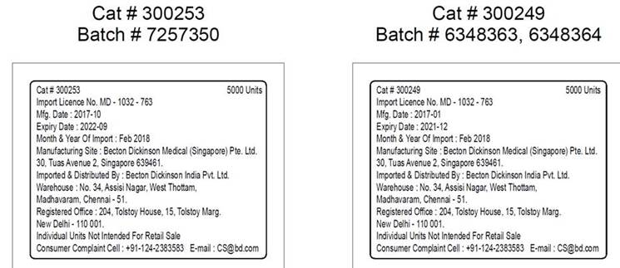

**From:** Karena Han [<mailto:Karena_Han@bd.com>]   
**Sent:** Tuesday, March 06, 2018 8:15 PM  
**To:** Jack, Fong; Rahamat, Mohd Syaiful Adli  
**Cc:** Tan, Wee Jian; Kio, Xi Xiang; Tat Shin Vun; Teck Seng Tan  
**Subject:** New labeling content for Hypoint product (India Labeling)

This is the new label content that I spoken to you all about.

Please advise the lead time to incorporate this change in WMS

•        **New content as per below**

1.      Units - Units per case

2.      Month & Year of import

3.      Warehouse

4.      Registered office

5.      Individual unit not intended for retail sales (Text)

6.      Consumer complaint cell

7.      Email

•        **Please find sample label**



WMS Information needed:

|  |  |
| --- | --- |
| **New field** | **WMS Field mapping/Logic** |
| Units | Unit per CASE ( EA per case) |
| Month & Year of import | ?? |
| Warehouse | WarehouseAddr (in SKU_LABELING master ) |
| Registered office | Can we use the Importer Addresses? (in SKU_LABELING master ) |
| Individual unit not intended for retail sales (Text) | Label Footnote (in SKU_LABELING master ) |
| Consumer complaint cell | ConsumerComplaintCell (in SKU_LABELING master ) |
| Email | New field (in SKU_LABELING master ) |

## May 05 Revised label – to remove warehouse address

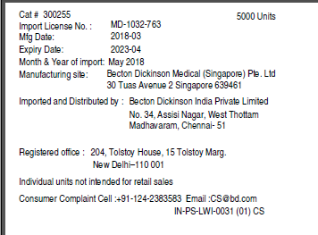

# WMS CHANGES:

## New label – CS Label Preview - phypoint

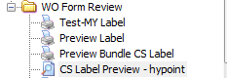

1005056424

123456

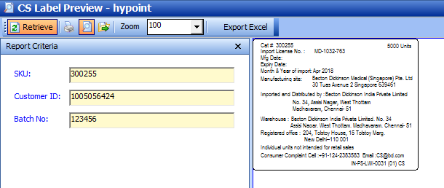

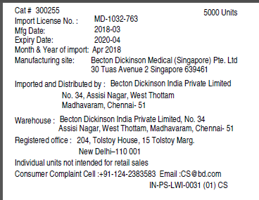

## SKU WORK ORDER MASTER

300249 HYPOINT NDL23GA1IN TW

300253 HYPOINT NDL25GA5/8IN

300255 HYPOINT NDL27GA1/2IN

300264 HYPOINT NDL30GA1/2IN

Added new Fields:

|  |  |  |  |
| --- | --- | --- | --- |
| Field name | Type | Data Length | Remarks |
| Emails | varchar | 100 |  |
| WarehouseAddr | varchar | 200 | 1 st line of Warehouse address |
| WarehouseAddr2 | varchar | 200 | 2nd line of warehouse address |
| RegisteredOffice | varchar | 100 | 1 st line of Registered off address |
| RegisteredOffice2 | varchar | 100 | 2nd line of Registered ofc address |

Note:

Label design FORM **= HYPLABEL**

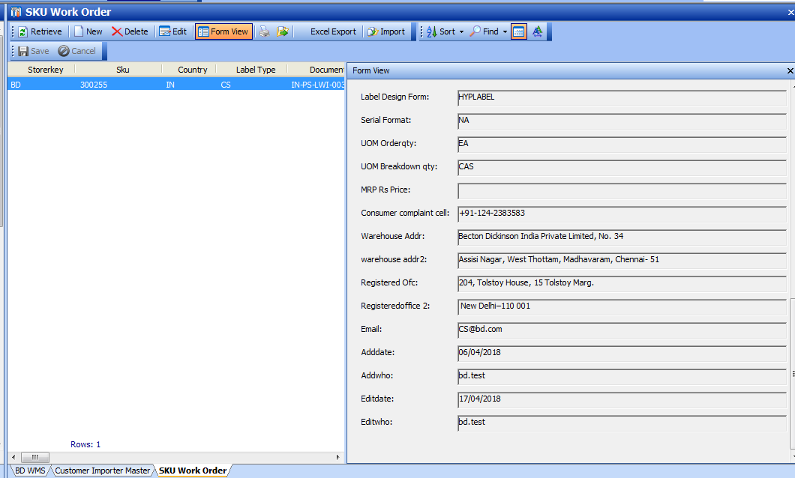

[2018.04.26] ADDED field Imp Date flag:

If “Y” = will display the Imp Date in WO form

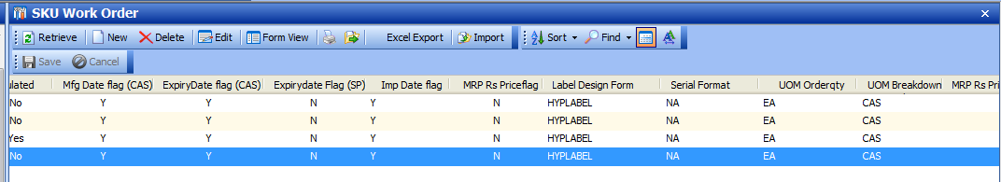

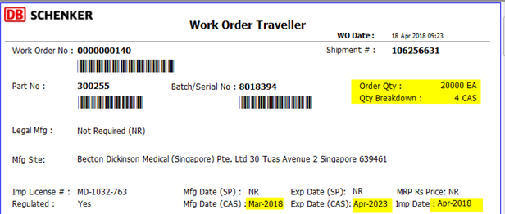

## Customer Importer Setup

Sample:

Sample: Customer ID 1005056424

(SETUP to be revised after received LWI)

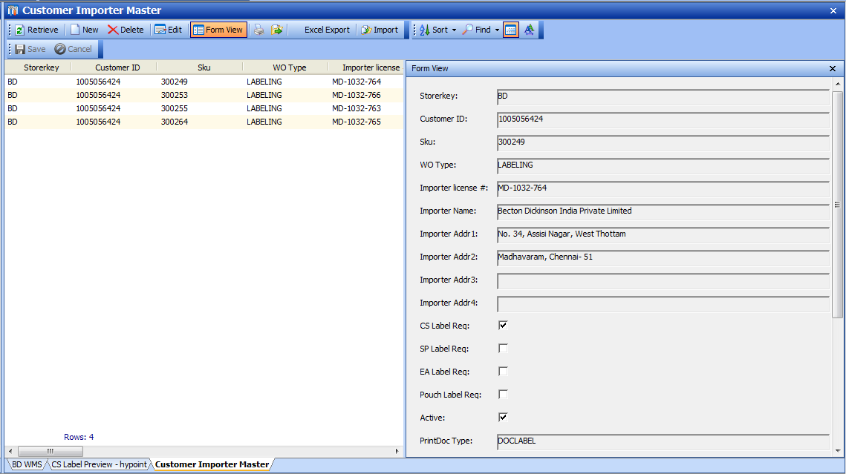

# Test Order

## Order

TO 0000810501

Shipment 106256631

SKU 300255

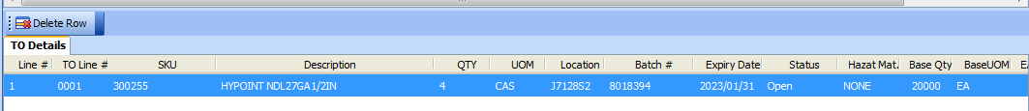

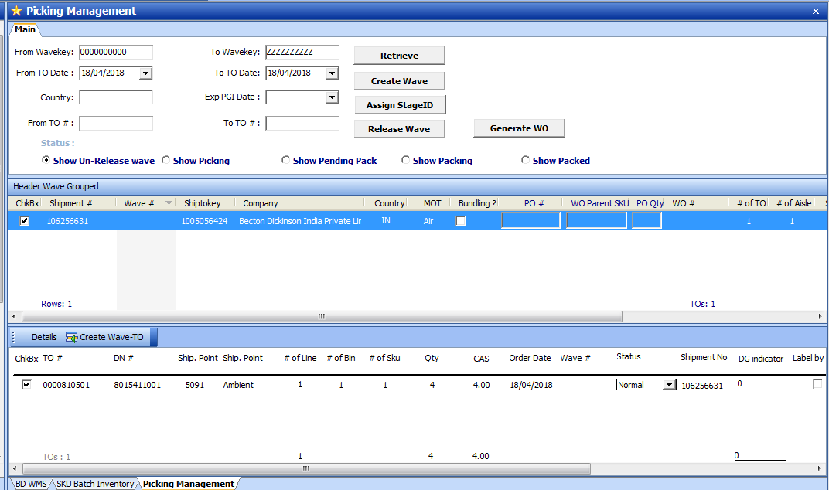

## Created WO

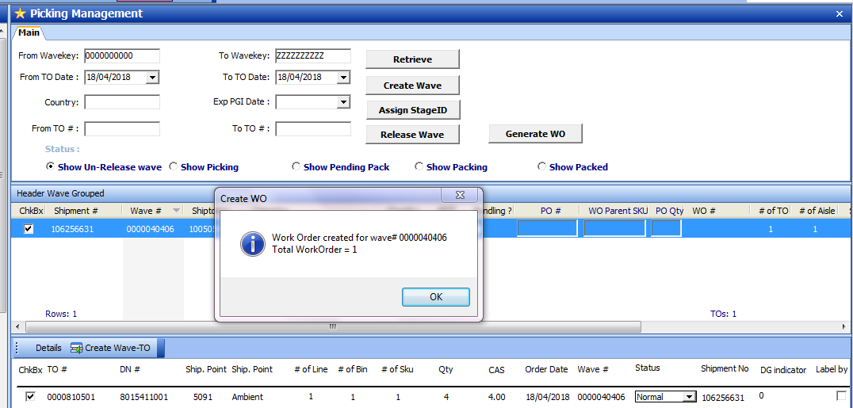

## Work Order Status update

WO# 140

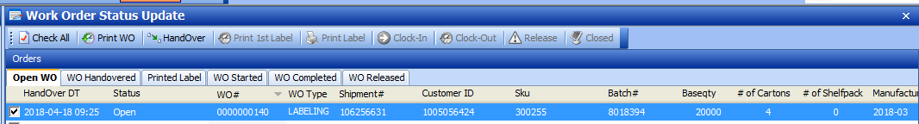

Printed WO

Handover

Print 1st label

